Four Square for Week Four
Clarify  W- word  S- Sentence  ?- I’m not sure  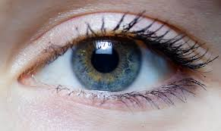- can’t picture this | Question  literal question  inferential question
Summarize | Predict  I predict:  My evidence is:

